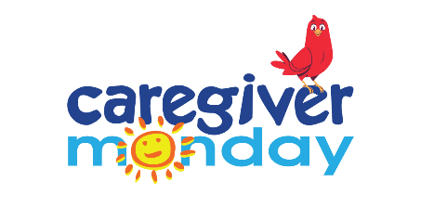
RECOMMENDED SOCIAL MEDIA MESSAGES TIMELINE
July 6 – September 28

Note: Partners are encouraged to use any of these graphic images in their caregiving communication efforts at any time. We invite you to create your personalized copy that relates to the Caregiver Monday messages below. We have listed certain occasions that tie into the specific assets and activities for those dates.
Remember to use our hashtag: #CaregiverMonday
July 6
July is National Sandwich Generation Month #SandwichGenerationMonth

July 13
July is National Sandwich Generation Month #SandwichGenerationMonth

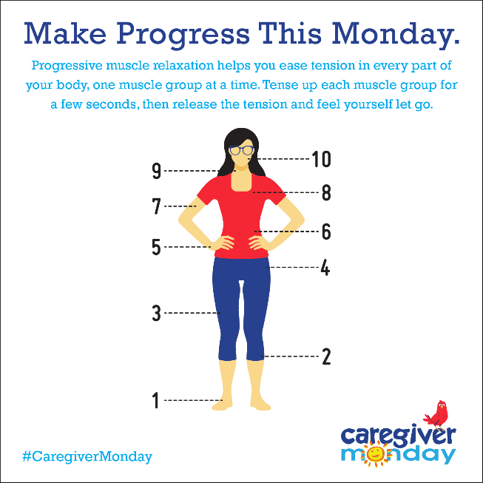

July 20
July is National Sandwich Generation Month #SandwichGenerationMonth

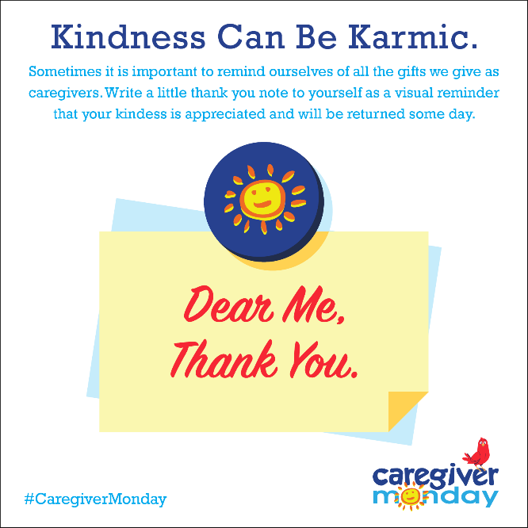

July 27
August 2 is National Friendship Day #NationalFriendshipDay2020
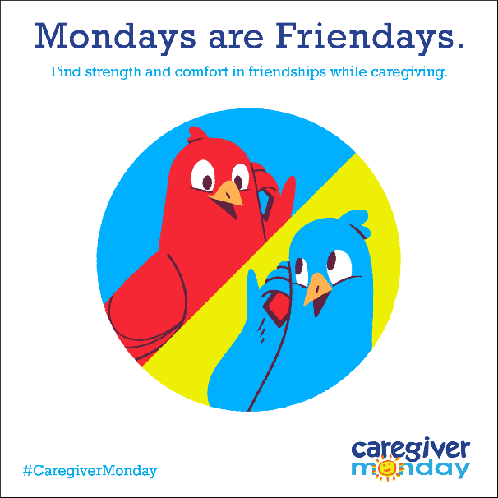

August 3
August is National Wellness Month #WellnessMonth
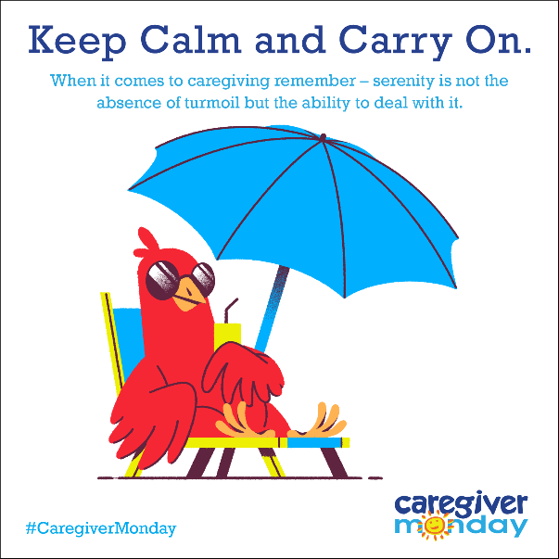

August 10
August 15 is National Relaxation Day #NationalRelaxationDay

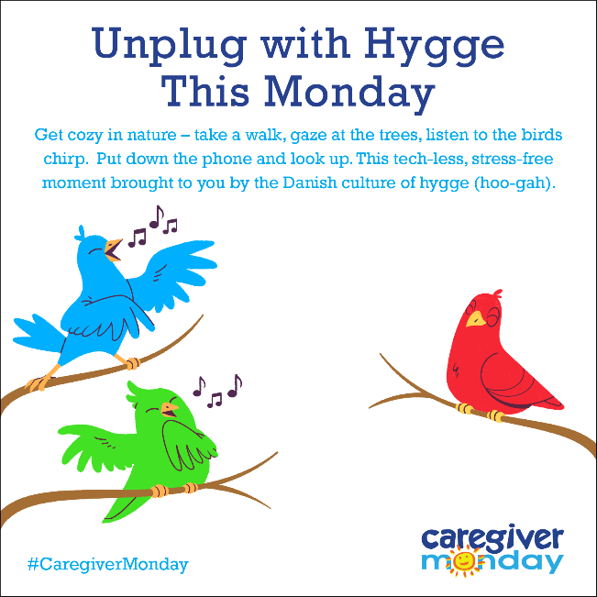

August 17
August is National Wellness Month #WellnessMonth

August 24
August is National Wellness Month #WellnessMonth

August 31
August is National Wellness Month #WellnessMonth
September is Healthy Aging Month #HealthyAgingMonth
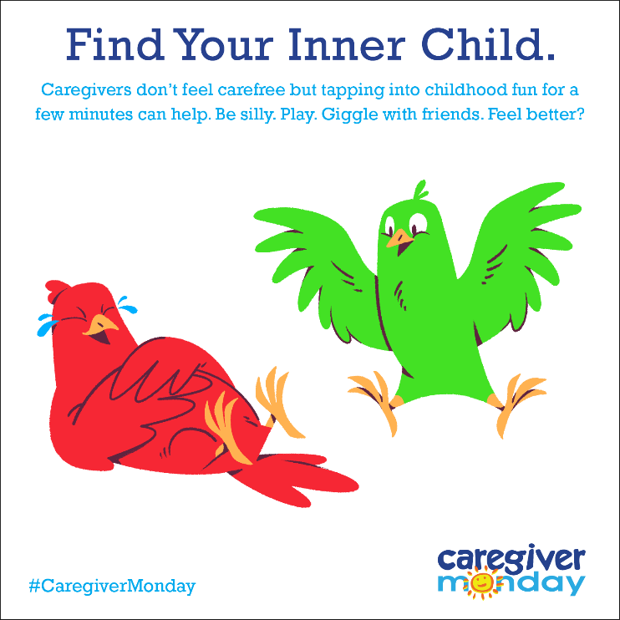

September 7
September 7 is Labor Day #LaborDay
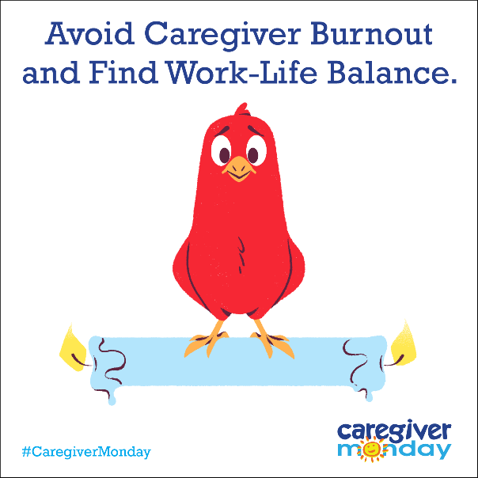

September 14
September is National Self-Care Month #NationalSelfCareMonth
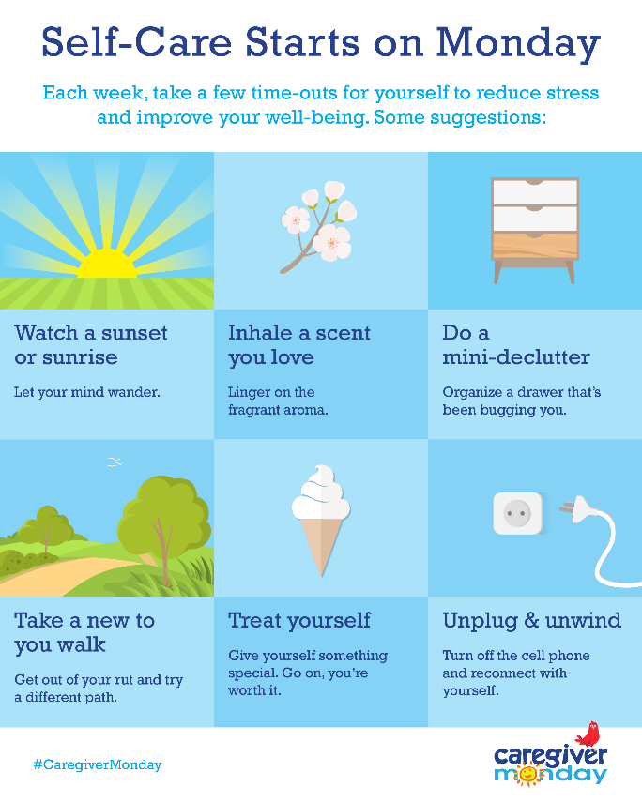

September 21
September 21 is World Gratitude Day #WorldGratitudeDay

September 28
October 2 is World Smile Day #WorldSmileDay

